DNA fragment analysis/restriction site mapping
Students name:
Lecturer:
Date :

4.
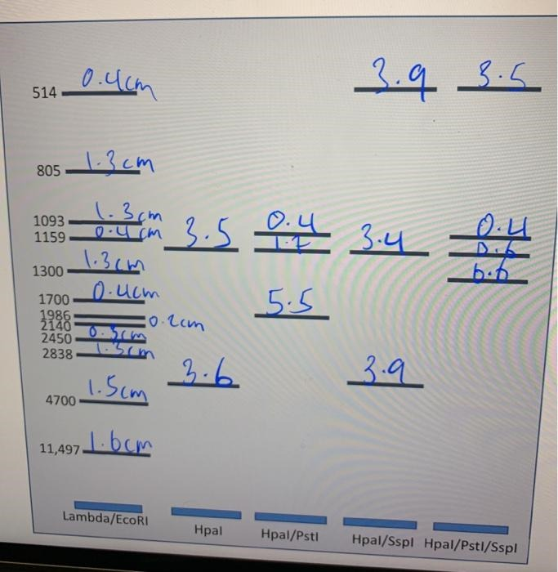

7.
H H

2Hpal
8.

PSH 1PSH
9.

1Sspl

10. The 500bp, 1000bp and 900bp fragments remain. The 1600bp fragment disappeared because it contains Pstl site.
11. The 500bp, 1000bp and 1200bp fragments remain. The 1300bp fragment disappeared because it contains an Hpal site.
12. The 400bp fragment. It appears only in the Sspl/Hpal/Pstl digest because it has an Hpal site on one end and a Pstl site on the other end.
13. A drawing of the plasmid map.
Sspl 500bp Sspl

1200bp

Pstl 400bp Hpal 900bp Sspl

